

International University of Information Technology

Department of Computer Engineering

**Laborotoy Work №12**

Complete by a student of the group: Ospan Ramazan it2-2310

Checked by senior lector of the Department of Computer Engineering:

Daurenbaeva Nurkamilya

Almaty 2024

Cyclic Redundancy Check (CRC) is an error-detection algorithm used in data communication systems. It ensures data integrity by appending a "checksum" to transmitted data. The receiver verifies the data by recalculating the checksum. If the result matches the received checksum, the data is considered correct; otherwise, an error is detected.

This report explains the theory behind CRC, step-by-step calculations, and practical implementation.

**Theory Overview**

CRC works by treating data as a binary polynomial divided by a fixed **generator polynomial**. The algorithm computes the remainder of this division, which acts as the checksum (CRC code).

Key concepts:

* **Generator Polynomial (G(x))**: A fixed binary sequence that defines the CRC algorithm's behavior. Examples:
  + CRC-4: *G(x)=x4+x+1G(x) = x^4 + x + 1*G(x)=x4+x+1 → binary: 10011
  + CRC-8: *G(x)=x8+x2+x+1G(x) = x^8 + x^2 + x + 1*G(x)=x8+x2+x+1 → binary: 100000111
* **Checksum**: The remainder of the division, appended to the data before transmission.

**Steps of the Algorithm**

1. **Define the Generator Polynomial**: Example: *G(x)=x4+x+1G(x) = x^4 + x + 1*G(x)=x4+x+1 → binary: 10011.
2. **Prepare the Data**:
   1. Original data: 11010011.
   2. Append *rr*r zeros to the data, where *r=degree of G(x)r = \text{degree of } G(x)*r=degree of G(x).
   3. New data: 110100110000.
3. **Binary Division**:
   1. Divide the data by the generator polynomial using XOR (modulo-2).
   2. Repeat until all bits are processed.
   3. The remainder becomes the CRC code.
4. **Attach the CRC Code**:
   1. Add the CRC code to the original data: 11010011 + 1010.
5. **Verification**:
   1. Perform the same division on the received data.
   2. If the remainder is 0000, the data is correct.

**Practical Example**

**Input**:

* Data: 11010011
* Generator Polynomial: 10011 (CRC-4)

**Steps**:

1. Append zeros:

Data with zeros: 110100110000

1. Perform division:

Step 1: 11010 XOR 10011 = 01001  
Step 2: 10011 XOR 10011 = 00000  
Step 3: 01000 XOR 00000 = 1010 (remainder)

1. CRC Code:
   1. Remainder = 1010
   2. Transmitted data = 110100111010.
2. Verification:
   1. Divide 110100111010 by 10011.
   2. Remainder = 0000. Data is correct.

Algorithm:

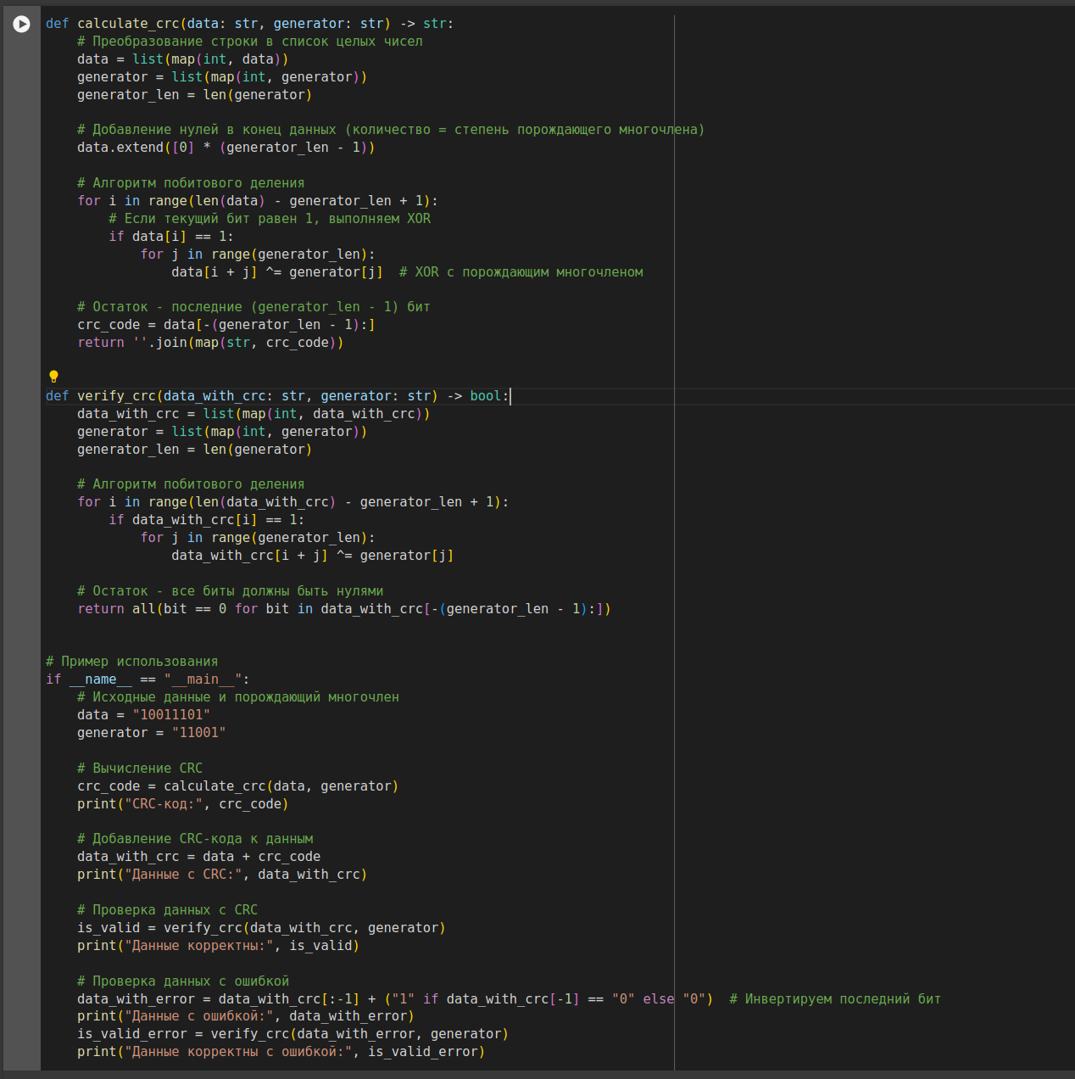

Test:

